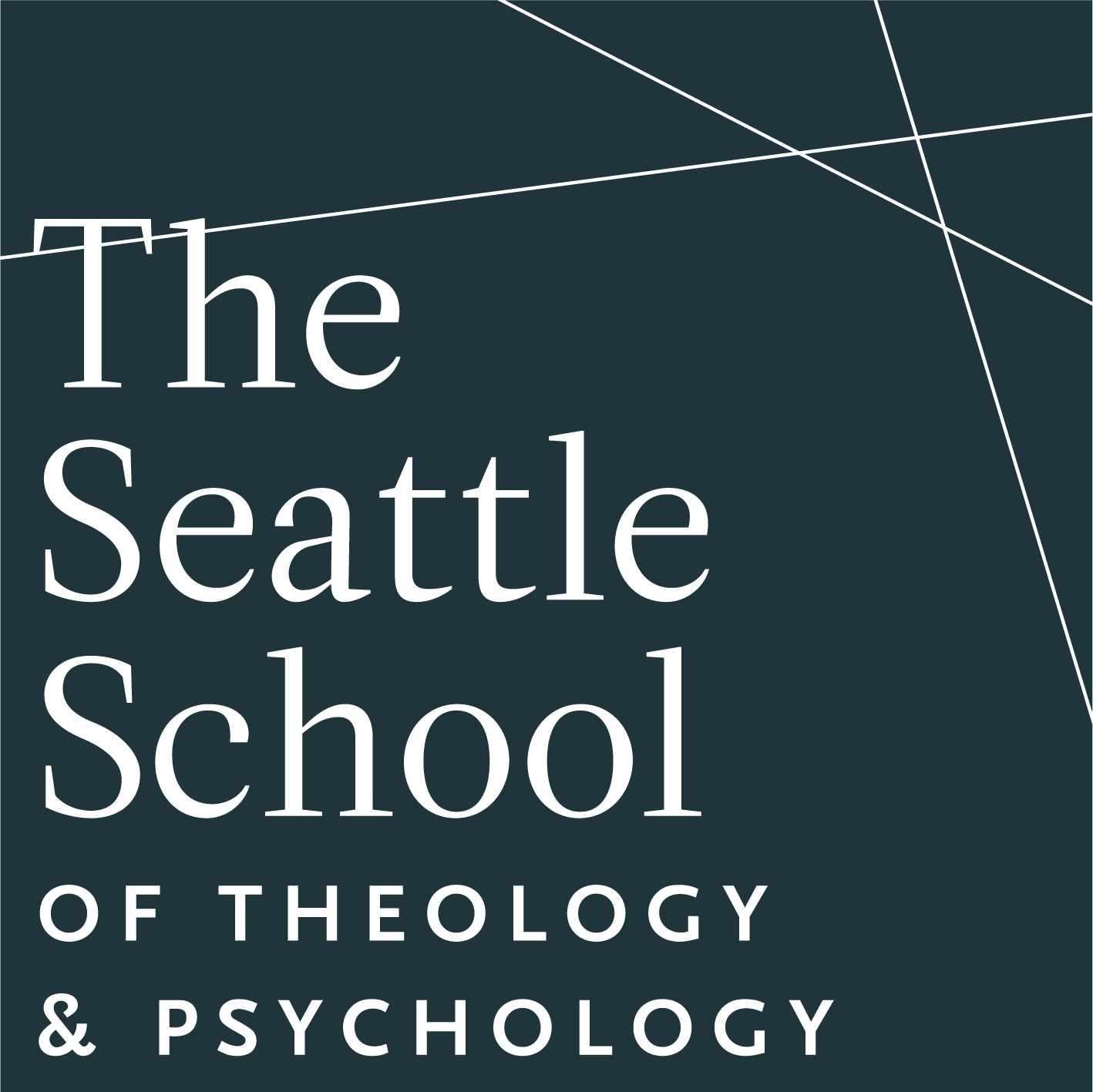
The Seattle School of Theology & Psychology (Seattle, WA) seeks to fill a Full-time Core Faculty Assistant Professor position in our Master’s Level Counseling/Psychology program. We are building a creative community that is robustly Christian, deeply questioning, and profoundly human. The ideal candidate would be committed to the interdisciplinary dialogue between theology and psychology, as well as intercultural engagement. Applicants from historically underrepresented groups are strongly encouraged to apply.

We seek candidates who are interested in growing into program leadership and who view clinical training coordination as an integral part of their professional development. For more information regarding essential functions and qualifications for this position, visit the “Current Openings” page on The Seattle School’s website.

To apply please submit a cover letter, curriculum vitae, teaching statement (which should include how their teaching would contribute to and advance a culture of diversity, equity, and inclusion) and an Employment Application (with a Statement of Faith) to facultyjobs@theseattleschool.edu. All inquiries and applications will be treated in confidence.

This position will remain open until filled, with preference given to applications received by Sunday, March 1, 2026.

