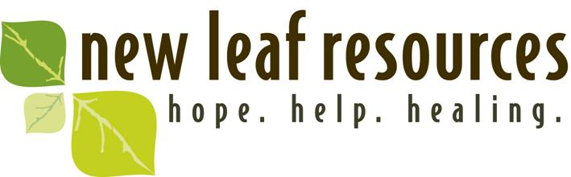
New Leaf Resources is seeking: 1) Clinical Director: Prefer Indiana licensed Psychologist (5 years+ experience) trained in psychological testing for children, adolescents, and adults; 2) Indiana licensed mental health counselors, marriage & family counselors, and clinical social workers to provide counseling to our clients (children, adolescent, adult outpatient clients). Applicants must seek to integrate their Christian faith in their professional work and be interpersonally skillful in working within a team setting.
Originating in the late 1970’s in Lansing, IL, New Leaf Resources is a 501(c)3 non-profit Christian organization, with additional offices in Crown Point, IN, and Wheatfield, IN. website: newleafresources.org
Our Mission -To promote healthy relationships, personal growth and healing through professional counseling, education and consultation from a Christian perspective.

Our Vision-To provide hope, help and healing to all in the South Chicago Metro area and Northwest Indiana region who would benefit from our services.

Our Philosophy-We believe that all people are created in God’s image and have immeasurable value, regardless of their life circumstances. As an organization and as individuals, we openly acknowledge our own brokenness and dependence on God’s healing grace and love in our lives. We believe that God works compassionately in the lives of people, calling and equipping us to participate in this ministry. There is a grace at work, the movement of God’s redemptive activity which calls upon the gifts, skills, training and experience of the staff to encourage, promote and facilitate this process of healing in our broken world. We seek to bring Christ-like care, restoration and hope in a manner which is sensitive to the complexity of the human condition, which includes the mental, emotional, physiological, social and spiritual dimensions.

We believe that ministry grows out of community. The quality of our staff life and the health of our organizational functioning are directly correlated with the quality of care we have to offer. In this ministry we seek to proclaim and embody God’s forgiving and reconciling love. It is our goal that God’s ministry of grace and love be reflected in our self-care, our communal life, and in the lives of those we serve.

Please send a cover letter and resume to: corky@newleafresources.org Or by mail: Corky DeBoer, New Leaf Resources, 2325 W. 177th St. Lansing, IL 60438.

