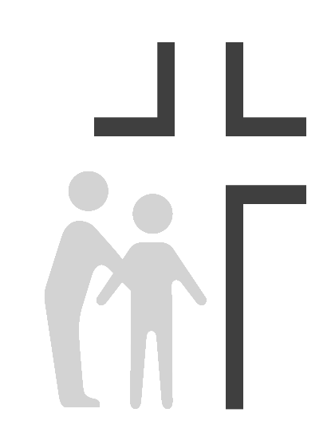
Good Samaritan Health Center of Cobb
Job Description
Behavioral Health Director/Primary Care Psychologist
Medical Assistant/Scribe

Effective Date: | 11/27/2018 | Reports To: | CEO
SUMMARY OF DUTIES: Good Samaritan Health Center of Cobb is a Federally Qualified Health Center (FQHC) that currently provides full service medical, dental, and medication dispensary services. The Behavioral Health Director is a Primary Care Psychologist who will assist in launching a new behavioral health service line that seeks to integrate Behavioral Health Consultants into our primary care services. The Behavioral Health Director will provide training, consultation, and oversight to Behavioral Health Consultants (BHCs) and will manage and direct the behavioral health services provided at the Good Samaritan Health Center of Cobb (GSHC). The Behavioral Health Director works collaboratively with the Medical Providers and Behavioral Health Consultants to provide integrated high quality behavioral healthcare to the patients of GSHC. The position is part-time (0.2 to 0.4 FTE).
PRIMARY RESPONSIBILITIES:
- Can fulfill the clinic’s mission to spread the love of Christ through quality healthcare to those in need while providing appropriate physical, emotional, and spiritual care for the whole person.
- Assist in developing and implementing system-wide standards of integrated behavioral health care in a primary care practice, utilizing evidence-based psychological methodology and practices including cognitive behavioral therapy and motivational interviewing
- Functions as the leader of the Behavioral Health Services of GSHC, providing clinical supervision of BHCs and training of BHCs
- Consultation and co-management of primary care patients utilizing psychological interventions, patient and family education, and team collaboration with primary care providers
- Monitor the site’s behavioral health program, identifying problems related to patient services and making recommendations for improvement.
- Participates in Continuous Quality Improvement Activities (CQI) and seeks to ensure quality of the behavioral health program.

EDUCATION:
- Doctorate degree (Ph.D/PsyD) in clinical or counseling psychology from a program accredited by the American Pychological Association (APA)
- Board Certification in clinical psychology, clinical health psychology, or a related area is preferred
- Current License in the state of Georgia
EXPERIENCE:
- Completion of an APA-accredited internship in a medical setting, formal training in clinical health psychology via the completion of a post-doctoral fellowship, or 2+ years of clinical experience in a medical setting

SKILLS:
- Ability to deliver and to teach evidence-based psychological interventions to treat and manage conditions common to primary care including but not limited to: depression, anxiety, insomnia, chronic pain, substance abuse, and chronic medical conditions
- Effectively uses screening and outcome tools
- Excellent and timely clinical documentation within an electronic health record
- Strong crisis management skills
- Full repertoire of behavioral health interventions including motivational interviewing, relaxation techniques, and other cognitive behavioral therapies
- General knowledge of psychotropic medications and chronic medical conditions common to primary care
- Can effectively train BHCs under his or her oversight
- Flexible, effective consultant that is able to work effectively on a primary care team
- Ability to demonstrate compassion and caring interacting with others in a way that supports the Center’s mission to share the love of Christ through high quality healthcare to those in need
ENVIRONMENTAL/ WORKING CONDITIONS:

- Combination of medical office and exam / procedure room setting which is a well-lit, well-ventilated, adequate space.

PHYSICAL/ MENTAL DEMANDS:

- Must be able to use appropriate body mechanics techniques when making necessary patient transfers and helping patients with walking, dressing, etc. Must be able to lift up to 40 pounds.
- Hearing / Speaking: Effective communications with patients, staff and visitors.
- Standing: 40% of the workday
- Sitting: 20% of the workday
- Walking: 30% of the workday
- Lifting: 10% of the workday

This description is intended to provide only basic guidelines for meeting job requirements. Responsibilities, knowledge, skills, abilities and working conditions may change as needs evolve.

